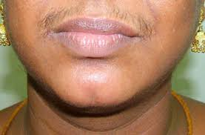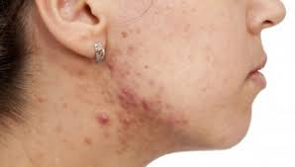

POLYCYSTIC OVARIAN SYNDROME (PCOS) ANALYSIS MEDICAL PROCEDURES

Polycystic ovary syndrome (PCOS) is a hormonal disorder common among women of reproductive age. Women with PCOS may have infrequent or prolonged menstrual periods or excess male hormone (androgen) levels. The ovaries may develop numerous small collections of fluid (follicles) and fail to regularly release eggs. The exact cause of PCOS is unknown. Early diagnosis and treatment along with weight loss may reduce the risk of long-term complications such as type 2 diabetes and heart disease.
Medical Procedures :
- Detailed medical history, to confirm definitive diagnosis
- Physical exam will include checking for signs of PCOS, including a pelvic exam. The attending physician will visually and manually inspects your reproductive organs for masses, growths or other abnormalities.
- Blood analysis to measure hormone levels. This testing can exclude possible causes of menstrual abnormalities or androgen excess that mimics PCOS. You might have additional blood testing.
- In some patients, an ultrasound may be advised to assess the appearance of your ovaries and the thickness of the lining of your uterus.
- If you have a confirmed diagnosis of PCOS, the attending physician may recommend additional tests for complications.
- Therapeutic Procedures: Medical Facials inclusive of herbal and vitamin infusions and injections such as zinc, vitamin c, vitamin B12.Body Treatments Include:Vitamin infusions and injections for skin healing, kojic acid natural skin lightening for pigmentation.Microneedling and face/body scrubs are available to aide with fast skin healing and repair.
Rejuvenation Treatment

Body scrubs,skin repair infusions and microneedling are options for skin repair in cases of Post-Treatment marks, scars or hyperpigmentation.
* see microneedling document.

Patient Consent:
Consent and authorization for this procedure are strictly voluntary. Signatures on the consent document authorize Europa medical spa and associated/ appointed offices/ professionals to use injection methods, medical or therapeutic skin repair methods/ with or without use of Lidocaine to perform procedures.

Patient Name:

Patient Selected Procedure:
_____________________ ____________________
Client Signature Witness Signature

