www.europaesmod.org

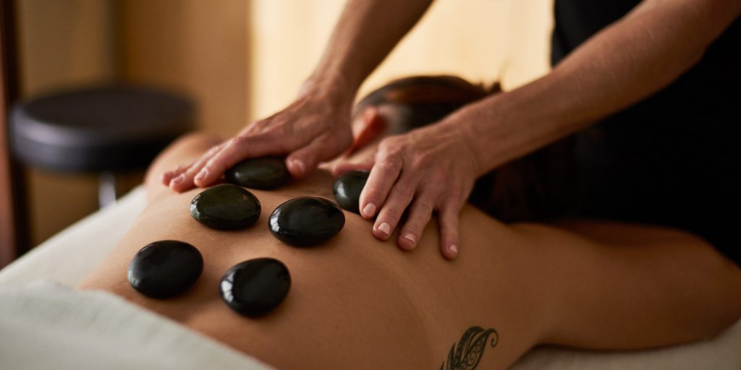

ONLINE BEAUTY EDUCATION - MODULAR COURSES

Without a doubt the best way to begin your journey as a beautician is to get started! Modular courses are short courses that allow a fast-track entry to the education and practice of beauty treatment by giving you a compact study layout with systematic progress online.

ONLINE TEACHING METHODS

Your Courses entail professional theory and practicals via bedside teaching demos done online Zoom Classroom. Student Practicals are done via online demos supervised by instructors. Students must obtain models for class to complete a system of demos that ensure all concepts and techniques are performed as required. Students are taught individually for their practicals online and in groups of 2-4 online for theory lectures.

CERTIFICATION

Online courses provide participation certification which indicates knowledge of work and not license for practice. Students can obtain local license via board exams in their country. We provide support online for preparations of different licensing exams for students aiming for those exams . Offline practicals are also an option and allows for higher professional certification. A facility / workshop fee applies per session. Offline practicals can be taken separately based on workshop schedules available from Europa International. Oral exams and procedure portfolios are the criteria for certifying via online our programmes.

SCHOOLS AND CERTIFYING PARTNERS
Our Europa Esmod Education Council is an international group of professional educators initially stemming from Europe. Our education programme is now Caribbean based with upcoming openings in New York City and re-entry to Europe in the united kingdom upcoming. Registrar office is currently Europa Medical Spa Ltd. Trinidad and Tobago. With Additional registered agent being Noire Luxury Spa, Port of Spain Trinidad.

BEAUTICIAN MODULAR COURSES: 3500.00TT ( 500 USD) per course
6 week programme 20 Teaching HRS /8hr practical portfolio.

- HD Face and Body Makeup L2

- Makeup & Spa Facials L1/L2 (foundation course required)

- Aesthetics & Resort Spa L1B/L2 (foundation course required)

ADVANCED MODULAR COURSES: 5000,00TT (700 USD)
8 week programme 40 Teaching hours/12 hour practical portfolio.

- Medical Spa Facials - Cystic Acne/ Dermatitis Focus

- THAI & Swedish Massages (post. Torso)

- Aromatherapy Massages: Face & Torso

- Rejuvenation Treatments - face & body

- Nathropatic Pain Management Massages

- Hyaluronic Anti-Aging Therapies

- Cellulite Treatments & skin refining
- Chemical peels & specialty resurfacing REGISTRATION INFORMATION
Course payment plans available at 40% down payment to start and a minimum of 2 sequential
fees. Material kits are at additional cost and international shipping fees at approximated cost 150.00-200 USD based on course selection. This is required by week 2 of courses. Fees are paid online and in person. Wire transfer and bank transfer information is available via contacts given below Start Dates are From March 25th Onwards.

Registration can be done via online forms at:
www.europaesmod.org/registration
www.paes.squarespace.com/vogueschool

In person registrations are available via office locations listed. Whatsapp for details on locations:
1-868-298-4295 / 1-868-776-3624

